**Building Web Applications in R with Shiny**

## Resources

data loaded before ui

[www.rstudio.com/resources/cheatsheets/](http://www.rstudio.com/resources/cheatsheets/)

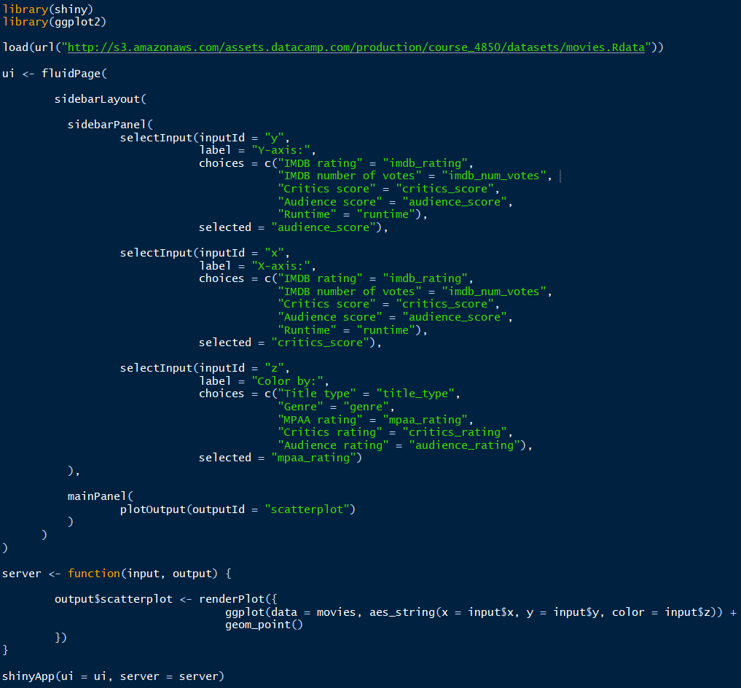[www.shiny.rstudio.com/](http://www.shiny.rstudio.com/)

controls the layout and appearance of the app

contains instructions needed to build the app

**UI**

creates the Shiny app object

Inputs are defined and laid out in the UI. Outputs are also laid out in UI.

The UI is translating everything into three languages:

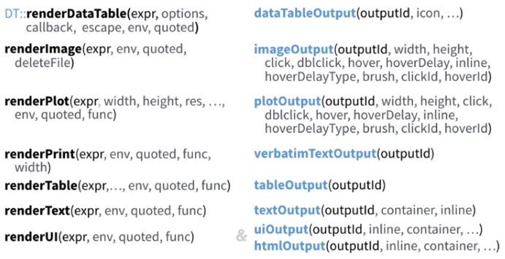

**Server**

Outputs are calculated in the server. Any other calculations needed for outputs are also performed in the server. The input and output in the server function are ***named lists***.

* Save objects to display to output$*
* Build objects to display with render*()
* Use input values with input$*